Release document-Milestone 1
Document ID: ASP-DRSYS-RD-01
Author(s): Rajesh K
Table of Contents

1. Sections Delivered 2
2. Perforce Check-in 2
3. Execution Machine 3
4. Machine Settings 4
Execution machine 4
Setup in New machine 4
5. Gem List 5
6. Execution Report 6
7. Jenkins Execution 6
8. User Defined Report 6
9. Deliverables Attached 7
10. Others 7

Sections Delivered
Milestone 1 contains deliverables related to AMC Stage 2 – Part 1 items which are mentioned in the Test Automation Plan.
The following sections constitute AMC Stage 2 – Part 1 section,
  - CPOE for Medication Orders
  - CPOE for Radiology Orders
  - CPOE for Laboratory Orders
  - Family Health History
  - Generate and Transmit eRX
  - Demographics
  - Record Electronic Notes

The “Automation Traceability document” covers the overall details of the deliverables.

Perforce Check-in
The scripts developed in Aspire are shared across to DRSYS using Perforce shared by DRSYS. The scripts of Milestone 1 are checked in under the location //SQA/eHR_SQA/eHR
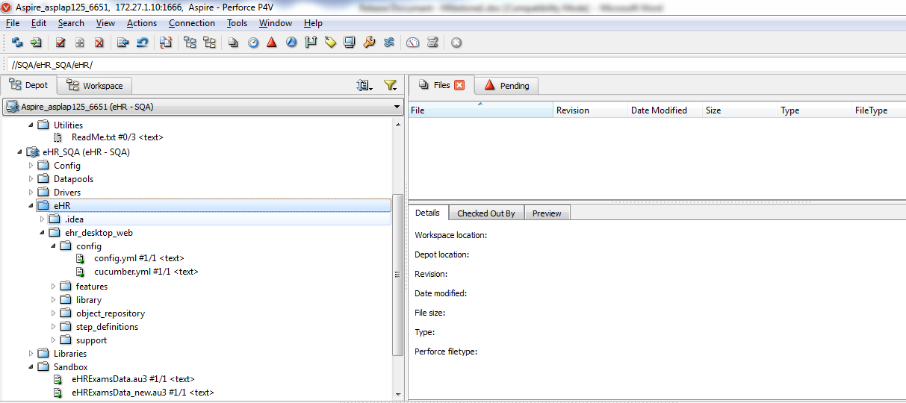

Execution Machine
As provided by DRSYS, the automation execution machine “172.27.101.114” will be used for testing the scripts by DRSYS QA. For now, the scripts are placed under the location “D:\Automation\eHR “. Two batch files “chrome.bat” and “internet_explorer.bat” are created and available in desktop. Based on the execution need, the batch files can be used.
Internet_explorer.bat: This will start the script execution through “Internet Explorer” browser.
Chrome.bat: This will start the script execution through “Chrome” browser.
Machine Details:
Machine IP: 172.27.101.114
Machine Name: VM-eHR-Automation
IE version: 11.0.9600.16384
Chrome Version: 38.0.2125.104 m

Machine Settings

Execution machine
All the necessary environment settings are already set in the execution machine “172.27.101.114”. This includes setting up of Ruby, gem files needed[see section 5], browsers, IE Driver server and chrome driver server. Ruby Mine is also installed in this machine to help in the debug of failed scripts. The license for Ruby Mine is also added.

Application details:
- Ruby – 2.0.0
- IE Server Driver – 2.41.0.0(32- bit)
- Chrome Driver - v2.11.298604
- Ruby Mine – 6.0.3

Setup in New machine
To setup the execution environment in other machines, please follow the below steps
Ruby Setup:
- To minimize the installation effort, you can copy the folder C:\Ruby200 from the automation machine 172.27.101.114 to the new machine. Make sure you copy the entire content of the folder to C drive in the target machine.
- Add the bin location of Ruby200 to the Path environment variable in the target machine
- Make sure the Run as administrator option is unchecked for IEDriverServer and ChromeServer [If this is not done, then the execution through the browser will not start]
- Set the value “172.27.101.113 VM-eHR-Aspire-AIO” in hosts file
- The site certificate should be installed to the machine

Gem List
Following gem files should be available in the machine where the script execution is targeted,
- bundler -v1.6.5
- win32ole-pp -v1.2.0
- nokogiri -v1.6.3.1 x86-mingw32
- cucumber -v1.3.15
- data_magic -v0.19
- selenium-webdriver -v2.43.0
- page-object -v1.0.2
- random_data -v1.6.0
- require_all -v1.3.2
- expectations -v2.0.0
- rspec -v3.0.0
- httparty -v0.13.1
- rubygems-update -v2.4.1
- shotgun -v0.9
- syntax -v1.2.0
- json_pure -v1.8.1
- rack-protection -v1.5.3
- libxml-ruby -v2.7.0 x86-mingw32
- pretty_face -v0.10.2
- time_difference -v0.3.2
- debase -v0.0.3

Execution Report
As discussed earlier, the current execution report consist of the following,
- HTML report : This is auto generated by Cucumber driver and has details of the complete execution
- Log Files : This can be used for report analysis purpose
- Screenshots: The screenshots for any failure is captured and the same is embedded to the HTML report. The file location of the screenshot is also mentioned in the log files generated.

Jenkins Execution
Automation script execution through Jenkins is performed in Aspire machine. The Jenkins setup for automation execution is yet to be done at DRSYS. The same will be done in the coming weeks after which the automation test execution in DRSYS will be initiated through the Jenkins site.

User Defined Report
The User defined report which was shared is not available with this release. When the test is executed in Jenkins, it too generated a HTML report with the help of a Jenkins plugin which is available. Analysis is being done in the same to check if we can use it as the execution report. If that does not suffice the need, then the shared user defined report will be generated and the same will be delivered with milestone2.

Deliverables Attached
Following are the deliverables which are shared with this release,
- Scripts [shared through Perforce as mentioned in section 2]
- Verification Points document
- Automation Traceability document
- IE Execution report – “IE_Complete Execution Report.html”[executed in automation machine – 172.24.101.114], attached in the email
- Chrome Execution report – “Chrome_Complete Execution Report.html “ [executed in automation machine – 172.24.101.114], attached in the email

Others
- eRX mailbox should be up and running without any issue in 172.24.101.113
- The medication “Acyclovir (Buccal) 50 mg” should be changed to controlled substance. This is the medication which is used for testing test cases related to controlled substance[Test Case id : 5812]

